 |  | 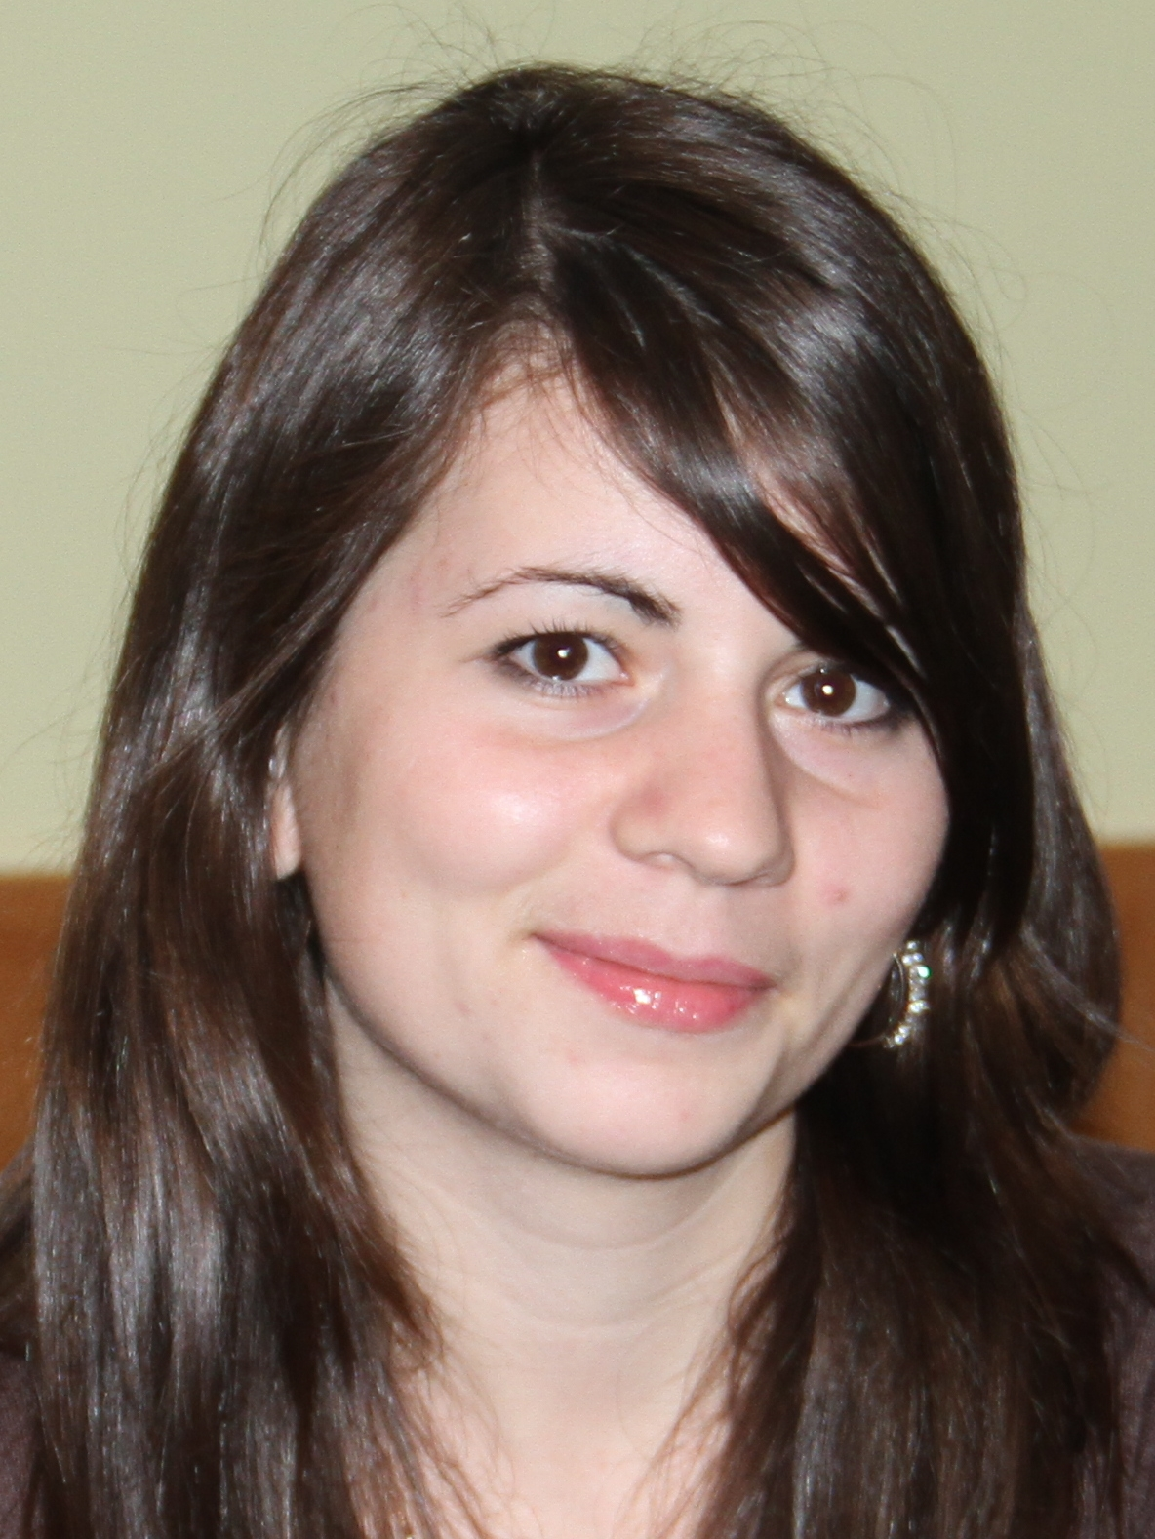
Europass
Curriculum Vitae
PERSONAL INFORMATION
First name(s) / Surname(s) |  | INNA CIVIRJIC
Address(es) |  | Chisinau, Moldova
Telephone(s)
E-mail |  | innareporter@gmail.com
Date of birth |  | 1989
Gender |  | Female
DESIRED EMPLOYMENT / OCCUPATIONAL FIELD
Work experience  Dates  Occupation or position held  Main activities and responsibilities  Name and address of employer  Type of business or sector |  | 7 years  August 2016 - onwards  Reporter  Investigation  RISE Moldova  Media
Dates |  | August 2014 – July 2016
Occupation or position held |  | Reporter
Main activities and responsibilities |  | Economy, financial sector (banks and insurance)
Name and address of employer |  | Online media «NEWSMAKER»  Chisinau, Moldova, MD-2009
Type of business or sector |  | Media
Dates |  | September 2013 – June 2014
Occupation or position held |  | Reporter
Main activities and responsibilities |  | Economy, financial sector (banks and insurance)
Name and address of employer |  | Online daily newspaper KOMMERSANT.MD,  INFINIT-MEDIA SRL
Type of business or sector |  | Media
Dates |  | August 2009 – august 2013
Occupation or position held |  | Reporter
Main activities and responsibilities |  | Politics, economy, health, social, culture, environment, sports
Name and address of employer |  | INFOTAG news agency
Type of business or sector |  | Media
EDUCATION AND TRAINING
Dates |  | 2011-2013
Title of qualification awarded |  | Master degree
Principal subjects/occupational skills covered |  | European journalism
Name and type of organisation providing education and training |  | State University of Moldova  Journalism
Dates |  | 2007-2011
Title of qualification awarded |  | Bachelor Studies
Principal subjects/occupational skills covered |  | Thesis Title «The role of public relation in the public administration»
Name and type of organization providing education and training |  | State University of Moldova  International Relation, Political and Administrative Sciences
Dates |  | September –December, 2010
Title of qualification awarded |  | Accounting courses
Principal subjects/occupational skills covered |  | Accounting
Name and type of organization providing education and training |  | Academy of Economic Studies of Moldova
Dates |  | 1997 – 2007
Title of qualification awarded
Principal subjects/occupational skills covered |  | School
Name and type of organisation providing education and training |  | School № 47 (lyceum A.Cehov - now)
PERSONAL SKILLS AND COMPETENCES
Mother tongue(s) |  | Gagauz, Russian
Other language(s) |  | Romanian, English

